1. **Are the HTML tags and elements the same thing?**

🡪No, HTML tags and elements are not the same thing, while they are closely related, there is a distinction between the two.

* **HTML Tags:**

🡪HTML tags are the building blocks of an HTML document.

🡪they are used to define the structure and content of a webpage.

🡪Tags are enclosed in angel brackets (< >) and are placed around the content they affect.

* **HTML Elements:**

🡪HTML elements, on the other hand, consist of both the opening and closing tags, as well as the content in between.

🡪Elements are used to define different parts of a webpage, such as heading, paragraphs, images and more.

1. **What are tags and attributes in HTML?**

🡪In HTML, tags and attributes play a crucial role in structuring and defining the content of a web page.

* **Tags:**

🡪Tags are the building blocks of HTML. They are used to enclose and define different elements within a web page.

🡪Tags are written as opening and closing pairs, with the content placed between them.

* **Attributes:**

🡪Attributes provide additional information about HTML elements.

🡪They are used to modify the behavior or appearance of an element.

🡪Attributes are always specified within the opening tag of an element and consist of a name and a value, separated by an equals sign (=).

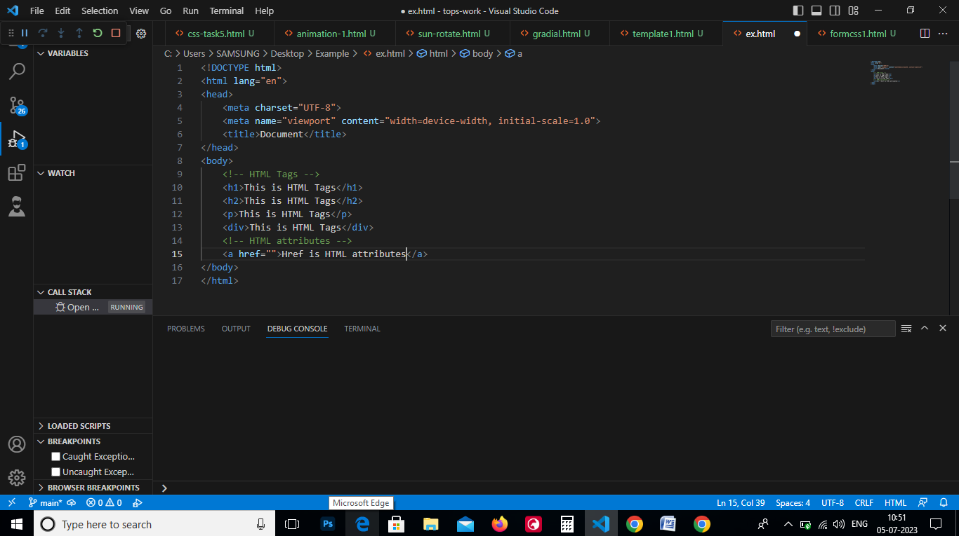

1. **What are void elements in HTML? With Example.**

🡪In HTML, void elements are elements that do not require a closing tag.

🡪They are self-closing elements and are used to insert content into a web page without any additional content or nested elements.

🡪Void elements are commonly used for inserting images, line breaks, or other standalone content.

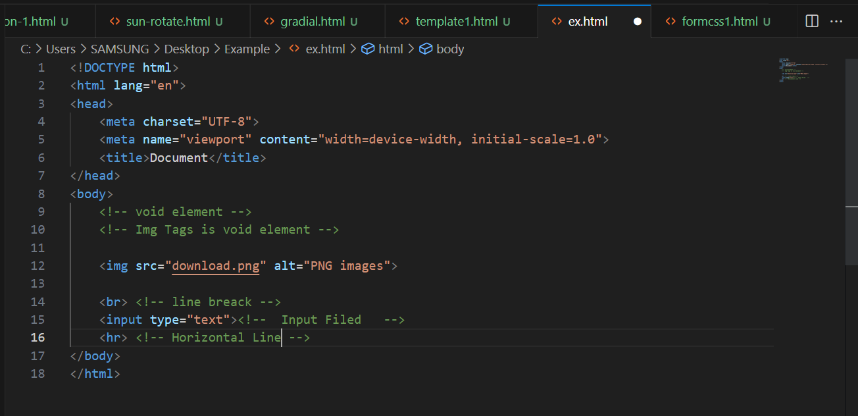

1. **What are HTML Entities? With Example.**

🡪HTML entities are special characters that are used to represent reserved characters or characters that have a special meaning in HTML.

🡪These entities are written using a specific syntax and are used to ensure that there characters are displayed correctly in web browsers.

🡪For Example, the less than symbol (<) and the greater than symbol (>) are reserved characters in HTML.

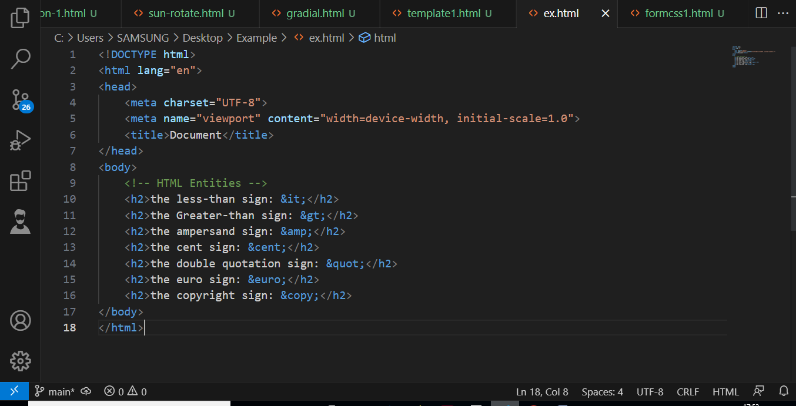

1. **What are different types of lists in HTML? With Example.**

🡪In HTML, there are three main type of lists:

1. Ordered Lists ( <ol> )
2. Unordered Lists ( <ul> )
3. Definition Lists ( <dl> )

* **Ordered Lists:**

🡪Ordered Lists are used when the order of the items is important.

🡪The items in an ordered list are automatically numbered or lettered by the browser.

* **Unordered Lists:**

🡪Unordered lists are used when the order of the items is not important.

🡪The items in an unordered list are displayed with bullet points by default.

🡪To create ab unordered lists, you can use the <ul> element, and each list item is defined using the <li> element.

* **Definition Lists:**

🡪Definition lists are used to present a list of term and their corresponding definitions.

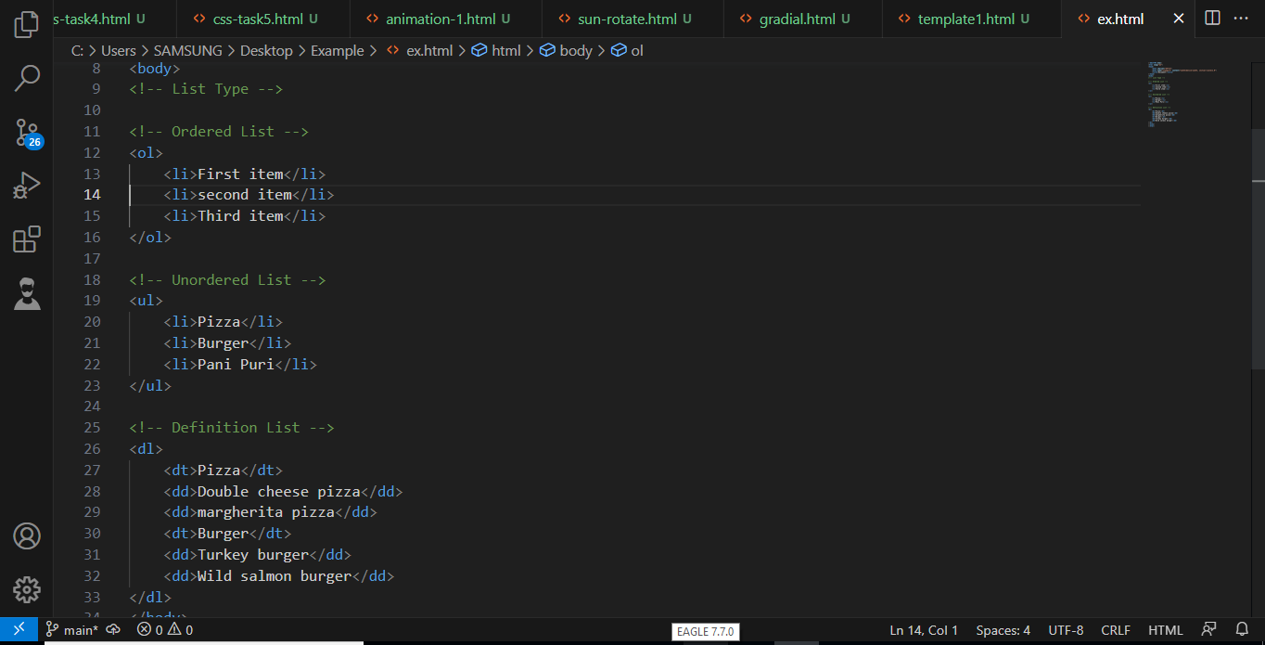🡪To create a definition list, you can use the <dl> element, and each term.

1. **What is the ‘class’ attribute in HTML? With Example.**

🡪The ‘class’ attribute in HTML is used to define a class for an element.

🡪It allows you to group elements together based on a common characteristic or style.

🡪By assigning the same class to multiple elements, you can apply styles or behaviors to all of them at once.

🡪The “class” attribute is written within the opening tag of an element and consists of one or more class names. Multiple class names are separated by spaces.

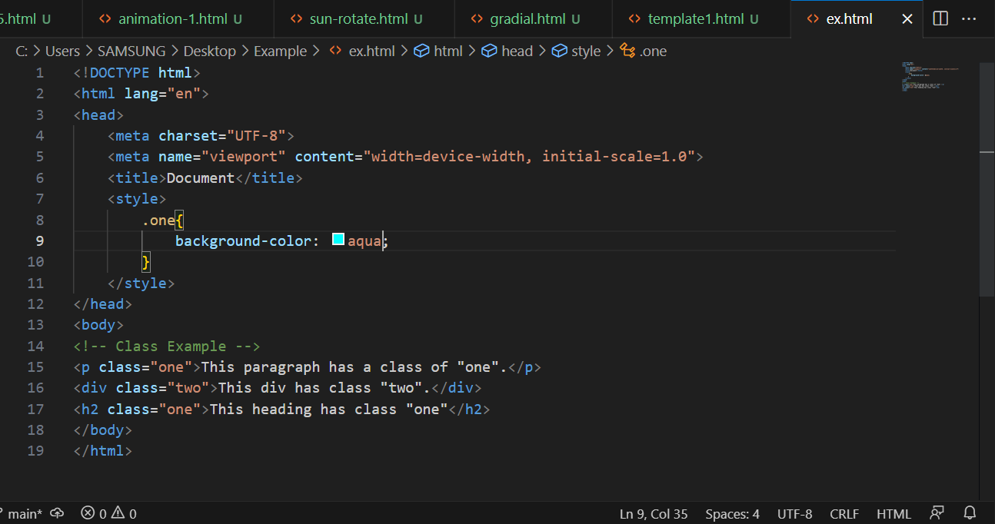

1. **What is the difference between the ‘id’ attribute and the ‘class’ attribute of HTML elements? With Example.**

🡪The “id” attributes and the “class” attributes are both used in HTML elements to provide additional information about the element.

🡪However, they have different purposes and usage.

🡪The “id” attribute is used to uniquely identify an element on a web page. It should be unique within the entire HTML document.

🡪This means that no two elements should have the same “id” value. The “id” attribute is often used to target specific elements with css.

🡪The “class” attribute is used to group element together based on a common characteristic.

🡪Multiple elements can have styled or manipulated as a group.

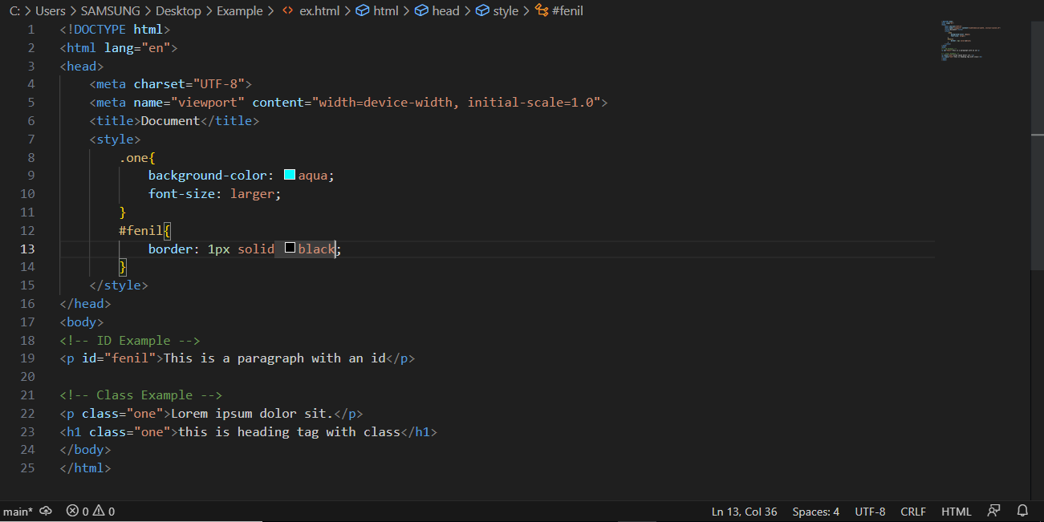🡪The “class” attribute e is often used to apply CSS styles to multiple elements.

**8) What are the various formatting tags in HTML?**

🡪HTML provides a variety of formatting tags that allow developers to structure and style their web content.

🡪These tags are used to modify the appearance of text, images, and other elements on a webpage.

🡪These tags provide a way to control the appearance and structure of the text.

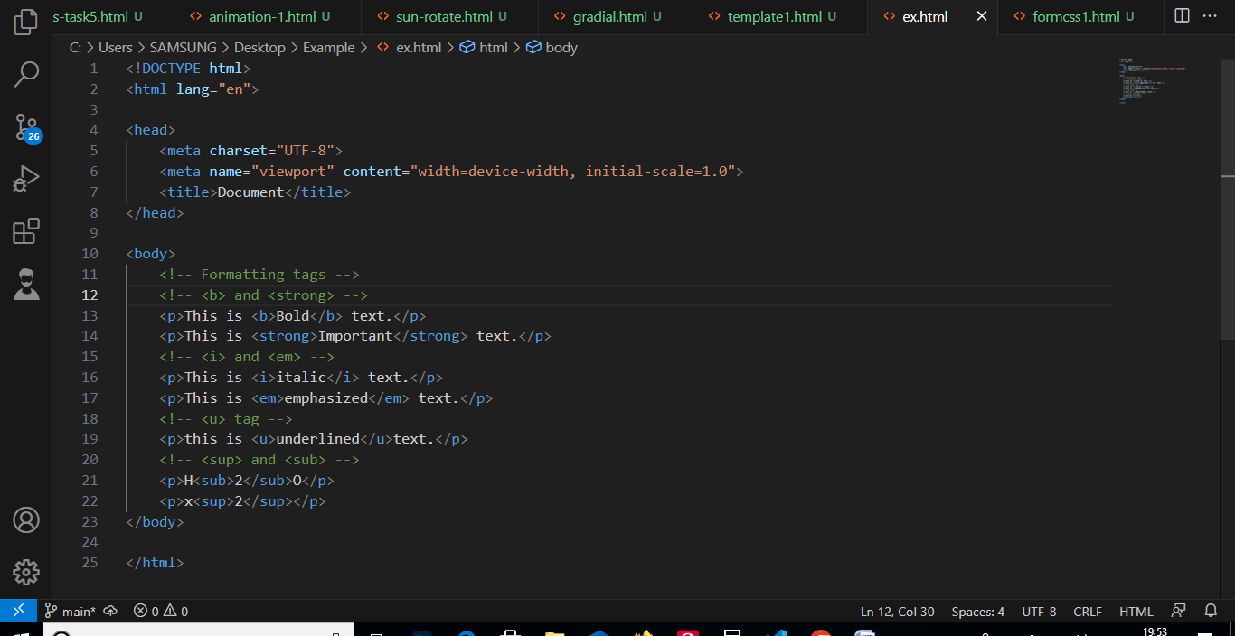**9) How is Cell Padding different from Cell Spacing? With Example.**

🡪Cell padding and cell spacing are two attributes used in HTML tables to control the spacing and alignment of content within table cells.

* **Cell padding:**

🡪Cell padding refers to the space between the content of a table cell and its border. It allows you to add extra space inside the cell, creating a gap between the content and the cell’s edges.

🡪The cell padding attributes is defined using the padding property in css.

* **Cell spacing:**

🡪Cell spacing, on the other hand, refers to the space between adjacent cells in a table. It controls the gap between cells, allowing you to add space between them.

🡪The cell spacing attribute is defined using the border-spacing property in css.

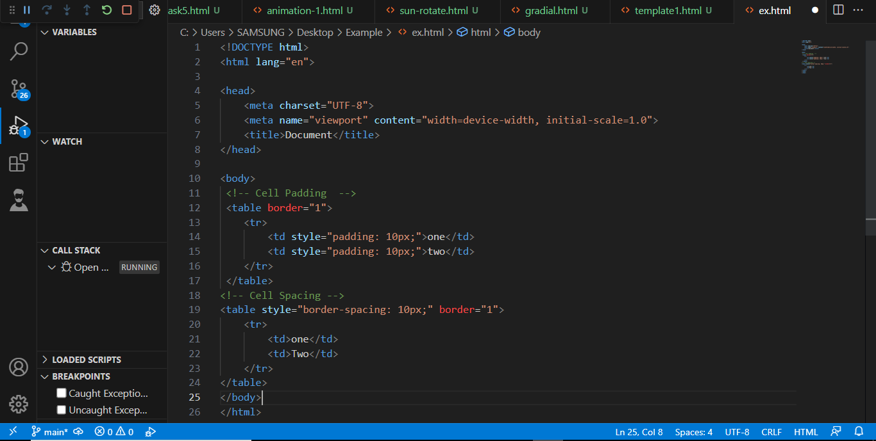

**10) How can we club two or more rows or columns into a single row or column in an HTML table? With Example.**

🡪To merge rows or colums in an HTML table, you can use the rowspan and colspan attributes. There attributes allow you to specify the number of rows or coloums that a cell should span.

**🡪Rowspan:**

🡪To merge rows, you can the rowspan attributes on a <td> or <th> element.

🡪The value of the rowspan attribute should be the number of rows that the cell should span.

**🡪Colspan**

🡪to merge columns, you can use the colspan attribute in a similar way.

🡪The colspan attributes specifies the number of columns that a cell should span.

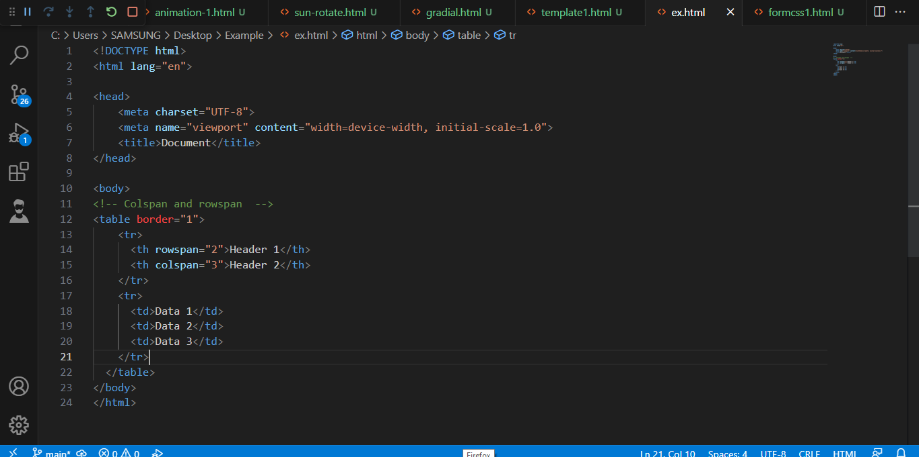

**11) What is the difference between a block-level element and an inline element?**

🡪In HTML, block-level elements and inline elements are two different types of elements that serve different purposes and have distinct behaviors.

🡪Block-level elements are those that create a block-level box on the web page.

🡪They typically start on a new line and occupy the full width available.

🡪Block-level elements are used to structure the layout of a web page and are often used for larger sections of content.

🡪Inline elements do not create new line and only occupy the space required by their content.

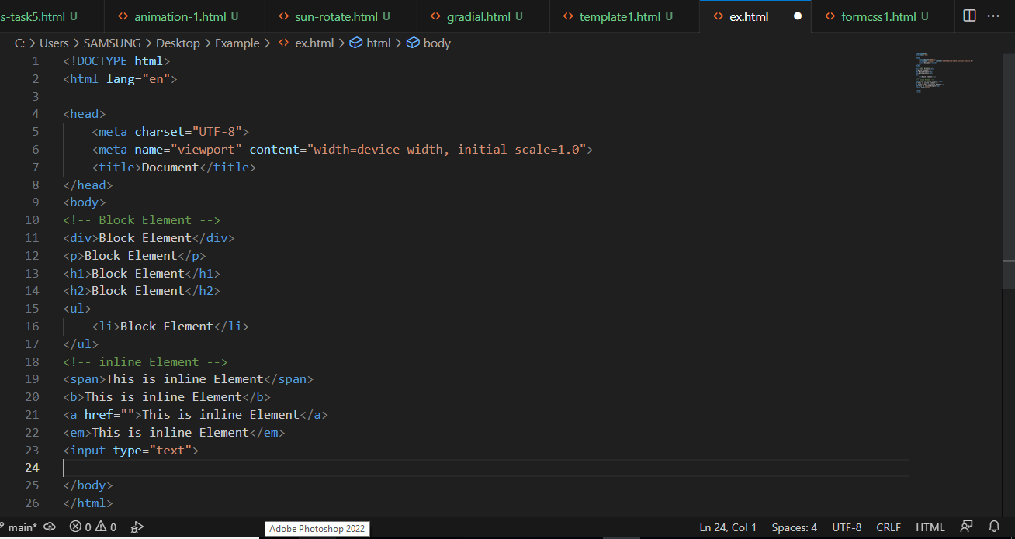🡪They are used to style and format smaller parts of the text within a block-level element.

**12) How to create a Hyperlink in HTML? With Example.**

🡪To create a hyperlink in HTML, you can use the <a> element, which stands for “anchor”. The <a> element is used to define a hyperlink, and it requires two attributes: href and text.

🡪The href attribute specifies the URL or the location where the hyperlink should navigate to when clicked.

🡪The text attribute specifies the text that will be displayed as the hyperlink. This is the visible part of the link that users can click on.

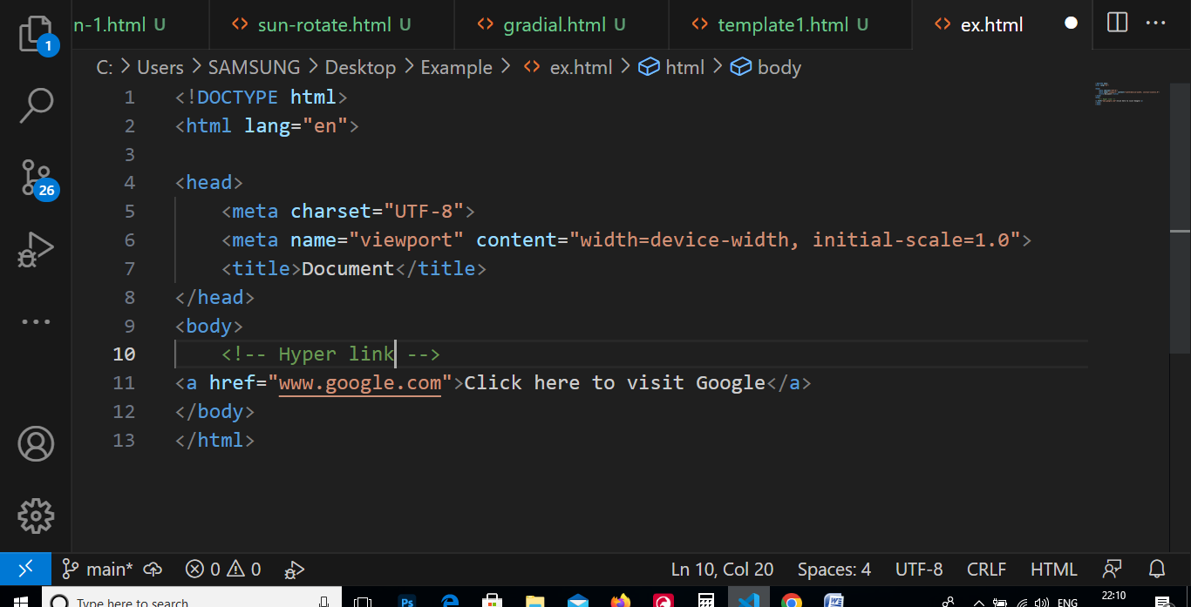

**13) What is the use of an iframe tag? With Example.**

🡪The <iframe> tag in HTML is used to embed another HTML document within the current document. It allows you to display content from another source, such as a webpage or a video, directly within your own webpage.

🡪This can be useful when you want to include external content or provide a seamless integration of different web resources.

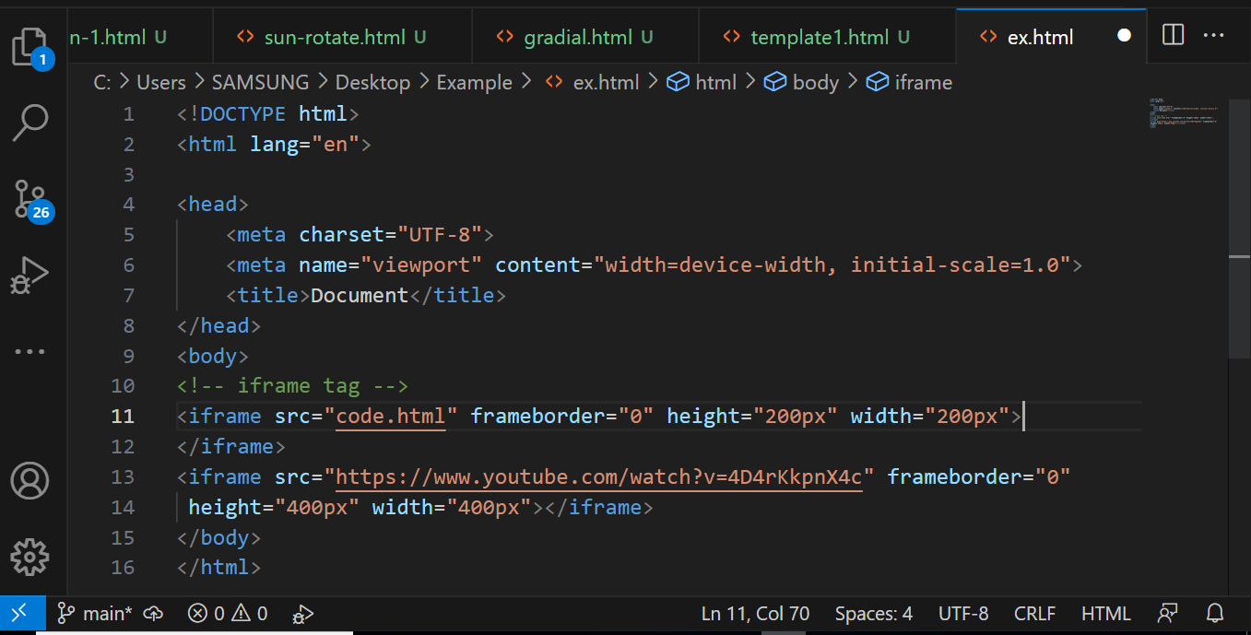

**14) What is the use of a span tag? Explain with example?**

🡪The <span> tag in HTML is an inline element that is use to apply styles or manipulate specific parts of a text within a larger block of content.

🡪It does not add any semantic meaning to the content, but rather server as a container for styling.

🡪One common use of the <span> tag is to apply CSS styles to a specific portion of text within a paragraph or heading.

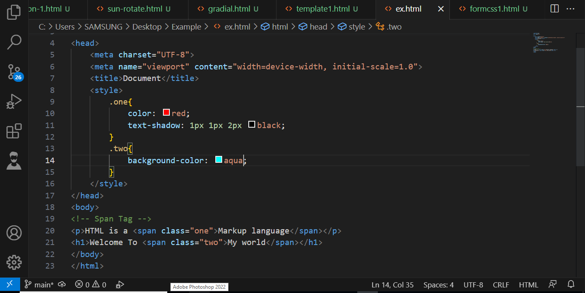

**15) How to insert a picture into a background image of a web page? With Example.**

🡪To insert a picture into the background image of a web page, you can use CSS to set the background images and position it accordingly.

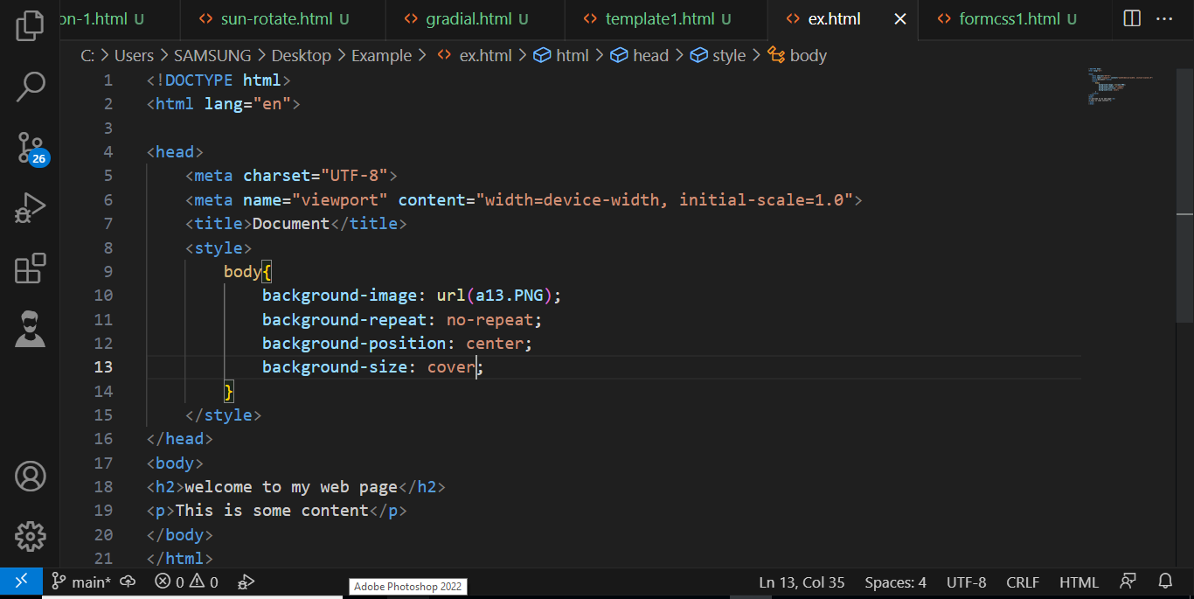🡪The “Background-image” property is used to specify the URL of the image file you want to use as the background.

**16) How are active links different from normal links?**

🡪Active links and normal links in HTML serve different purposes and have distinct characteristics.

🡪Normal links, also known as static links, are the most common type of links used in HTML.

🡪They are used to navigate between different web pages or sections within a web page.

🡪Normal links are created using the <a> element and the href attribute, which specifies the destination URL. When a user clicks on a normal link, the browser loads the linked page or jump to the specified section within the same page.

🡪Active links, also referred to as dynamic links, are links that change their appearance or behavior based on certain conditions or user interactions.

**17) What are the different tags to separate sections of text?**

🡪HTML provides several tags that can be used to separate sections of text. These tags help in organizing and structuring the content of a webpage.

* <h1> to <h6>: These tags are used to define heading of different levels. The <h1> tag represents the highest level heading, while <h6> represents the lowest level heading.
* <p>: The <P> tag is used to define paragraphs of text. It is commonly used to separate blocks of text and provide structure to the content.
* <div> : The <div> tag is a generic container that can be used to group and separate sections of text.

**18) What is SVG?**

🡪SVG stands for Scalable Vector Graphics.

🡪It is a markup language used to describe two-dimensional vector graphics. SVG is an XML-based format that allows developers to create and manipulate graphics using code.

🡪SVG images are composed to mathematical shapes and can be scale without losing quality.

🡪SVG is widely used in web development because of its flexibility and scalability.

🡪It Allows developers to create interactive and dynamic graphics that can be easily integrated into HTML documents.

🡪One of the main advantages of SVG is its ability to adapt to different screen sizes and resolutions.

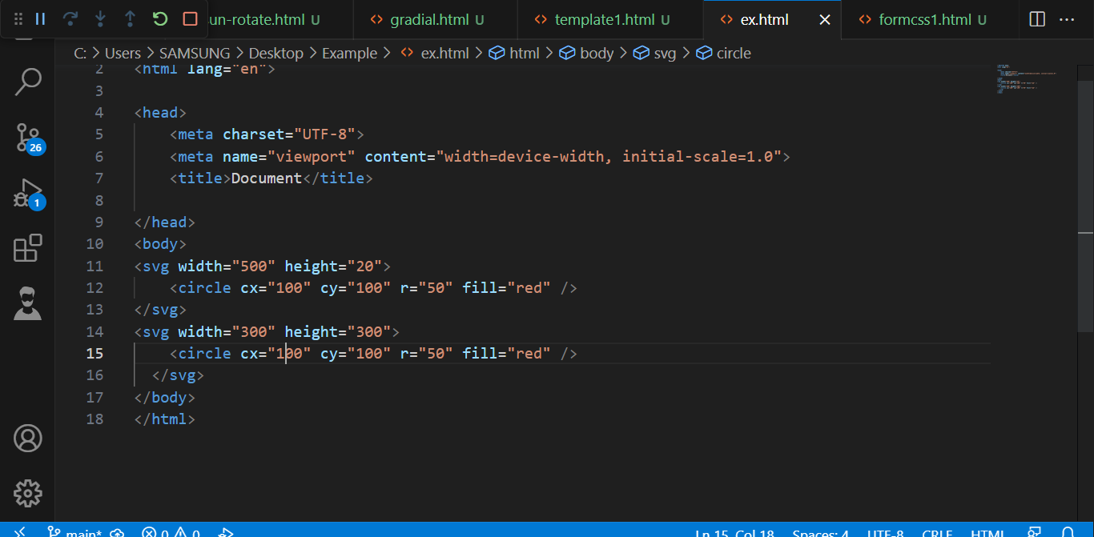

**19) What is difference between HTML and XHTML?**

🡪HTML (Hypertext Markup Language) and XHTML (Extensible Hypertext Language) are both markup languages used for creating web pages. While they share similarities, there are some key differences between the two.

🡪One of the main differences between HTML and XHTML is the syntax they use.

🡪HTML has a more forgiving syntax, allowing for unclosed tags and other errors.

🡪On the other hand, XHTML follows stricter rules and require well-formed XML syntax. This means that all tags must be properly closed, attribute values must be enclosed in quotes, and elements must be nested correctly.

🡪HTML and XHTML also differ in their document structure. HTML documents have a more relaxed structure.

🡪XHTML, on the other hand, has a stricter structure and requires all elements and attributes to be properly defined and closed.

**20) What are logical and physical tags in HTML?**

🡪In HTML, tags are used to structure and define the content of a web page. There are two main types: logical tags and physical tags.

* **Logical Tags:**

🡪Logical tags, also known as semantic tags, are used to describe the meaning and purpose of the content they enclose.

🡪These tags provide a way to structure the content in a way that is meaningful and understandable to both human and search engines.

🡪Example:

🡪<Header> : Represents the introductory content or a group of navigational links at the top of a web page.

🡪<nav> : Defines a section of navigation links.

🡪<Main> : Specifies the main content of a web page.

🡪<article> : Represents a self-contained composition that can be independently distributed or reused.

* **Physical Tags:**

🡪Physical Tags, also known as presentational tags, are used to define the appearance or presentation of the content they enclose.

🡪These tags are primarily used for styling purpose and do not convey any specific meaning or structure.

🡪Example:

🡪<b>: Represents bold text.

🡪<i>: Represents italicized text.

🡪<u> : Represents underlined text.

🡪<center> : Centers the content horizontally within its container.

**21) Create below example using only HTML tags without CSS.**

